**OPTIMUS**

In pursuance of improved productivity, companies increasingly rely on group cohesion and motivation to reach their objectives. Therefore, management committees, team building programs, and corporate events have been experiencing a huge boost in popularity and this tendency is bound to escalate over the next years.

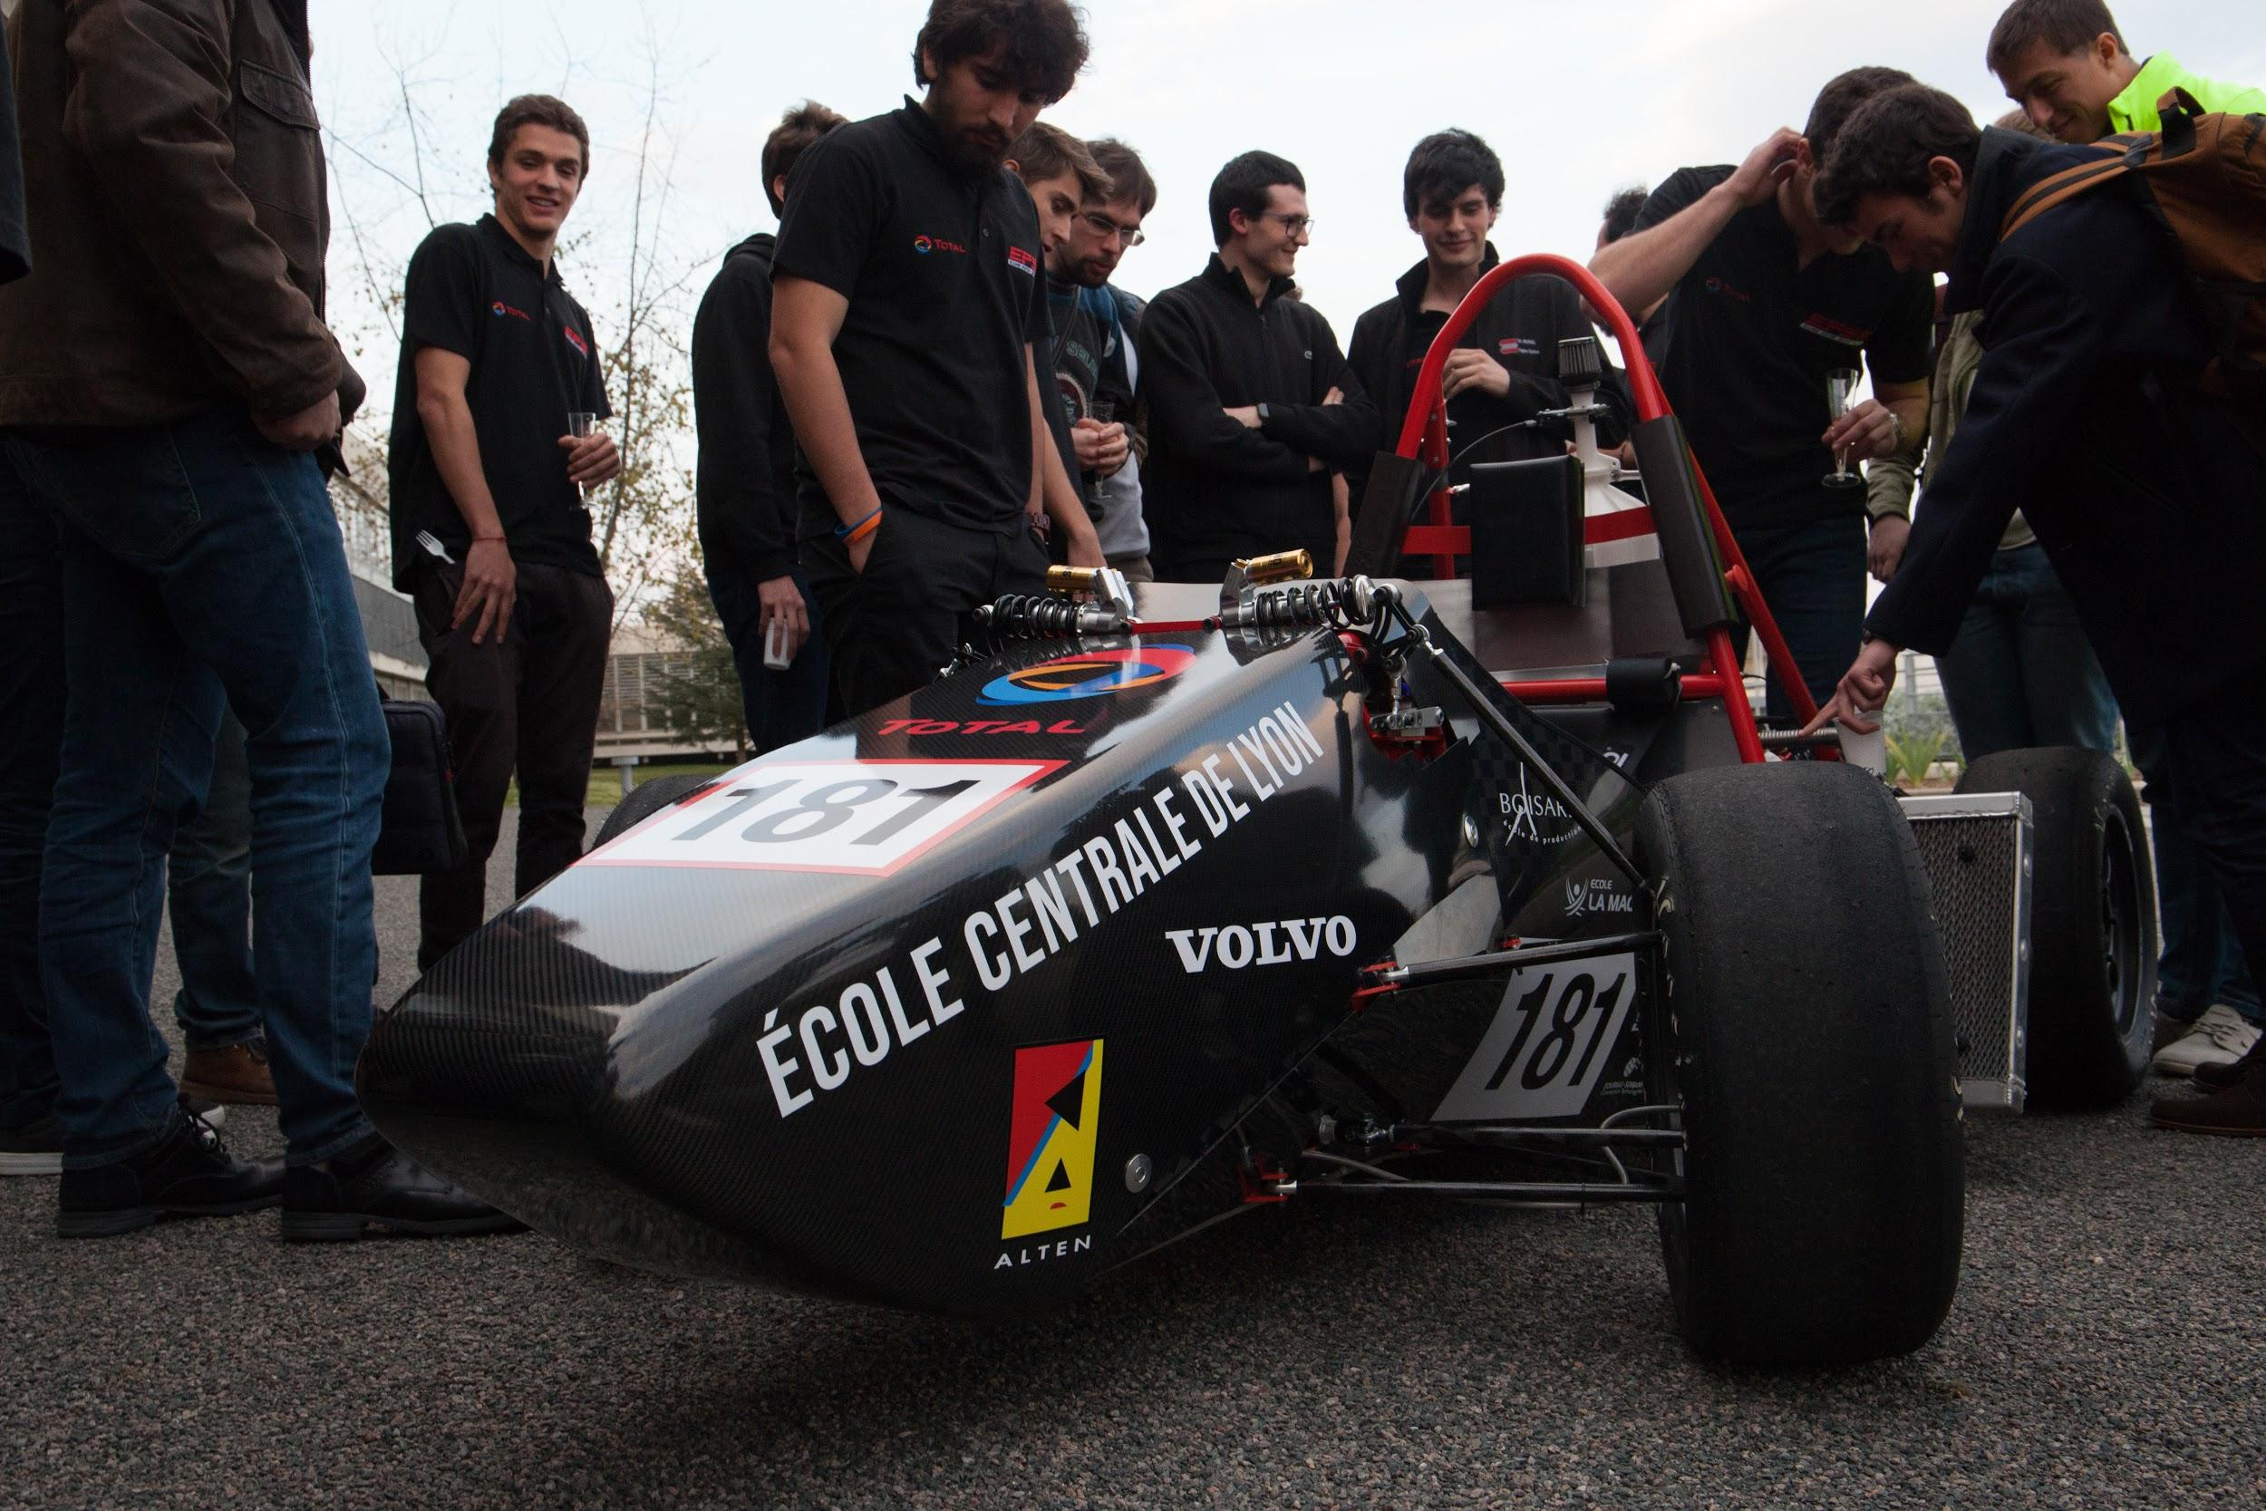

Our start-up, Optimus, aims to become a reference in the field of team building seminars. We offer **Vehicle Assembly and Driving seminars** for firms and groups that seek to offer a creative, cohesive and thrilling experience to their members around the design and driving of a formula type vehicle.



Our offer attracts all-sized corporations, mainly because hiring our team is more cost-effective than developing equivalent projects in-house. Even more budget-limited companies and local clubs seek to enhance their team spirit through such events: we provide everyone with **long-lasting collective memories**.

We will have to compete with other corporate events-planning businesses. However, activities related to motorsport are often under-represented, and usually do not give a genuine **insight** of the car itself and its assembling process.

This project is led by Ms DILLARD, Mr CLAMENS and Mr KIEFEL, who will respectively be in charge of the commercial aspects, the organization and logistic, and lastly the technical facets of the seminars. Each has great experience in their domain and the group was proven to be symbiotic.

According to our financial expectations and market analysis, we expect a **full return of investment in less than three years**, and to multiply profit by more than six after the first five years.